**My Introduction website:**

**BRIEF OVERVIEW OF THE PROJECT AND THE LIST OF FEATURES:**

* In that we create a different option for user like first of home , menu ,contact, about
* Then we add an option to select a choice for intership and traing
* We also added a about personal description,table content images,
* We also added button option in it
* We also added map call address feedback option
* Model content ,tab content
* Collapsible nav for mobile

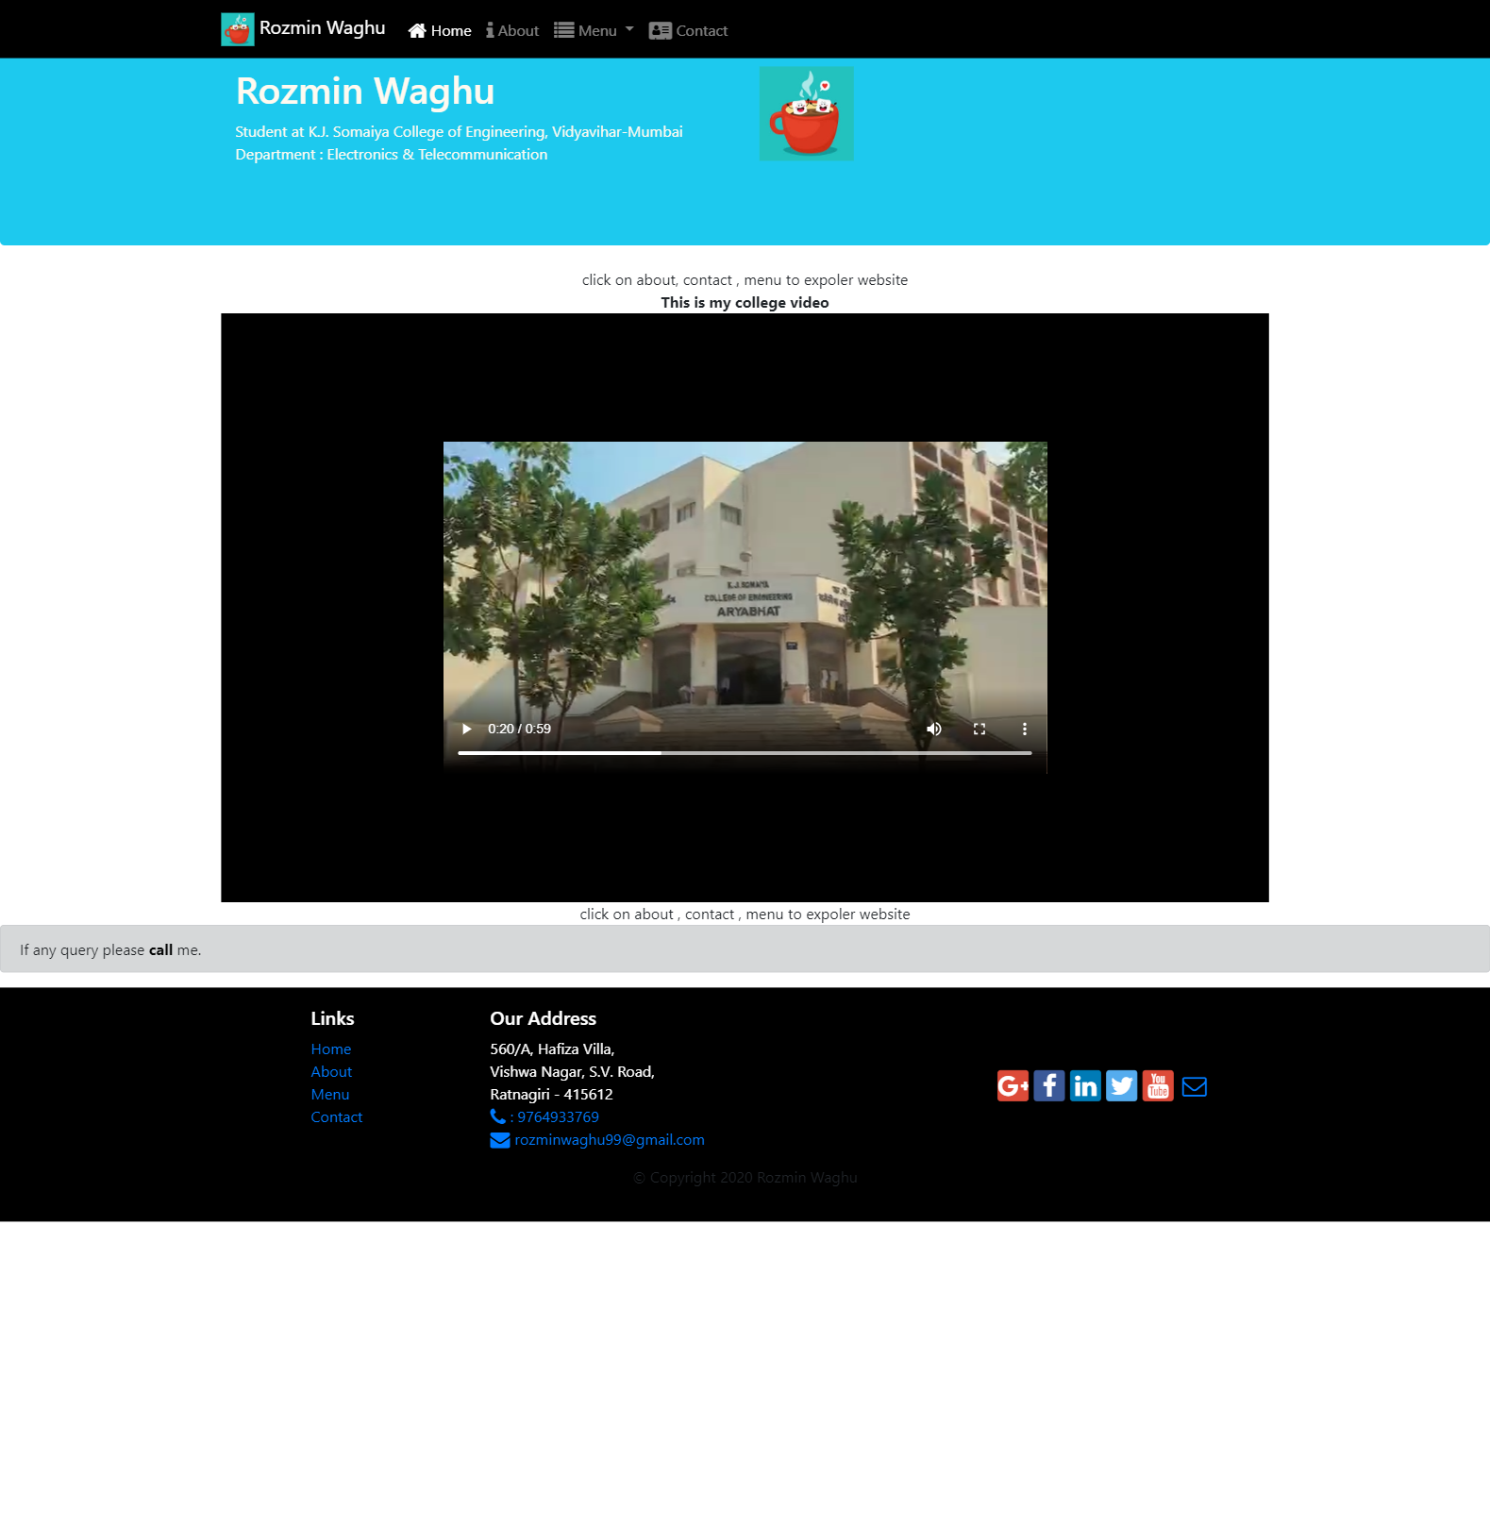

**For mobile**



